Messaging Toolkit for Child Care and Out of School Care Programs: Celebrating the Holidays and Winter Break
New information is in orange.
On December 15th Governor Phil Scott put additional measures into place to slow the spread of COVID-19 in Vermont. During his December 22nd media briefing, Governor Scott made temporary changes to the policy that will impact your community.

What Families Need to Know
- For the 10-day period of December 23, 2020 through January 2, 2021, one household may gather with one other trusted household. That is a maximum of two households gathering during this time.
- Staying home and with people in your household is still the lowest risk.
- Gathering with people you do not live with is not recommended for those who are at higher risk of serious illness from COVID-19 or the people who care for them.
- If you do gather, the Health Department strongly encourages getting tested 7 days afterwards.
- If you gather with anyone from out of state, everyone in both households must quarantine for 14 days, or 7 days with a negative test.
- The Health Department strongly advises against non-essential travel, even within Vermont. All travel to and from Vermont requires quarantine.
Plan to Stay Safe
For a lot of families, holiday celebrations are built around traditions that bring people together. After an extended time being apart, we need connection more than ever. However, our individual choices can have a large impact the health of our community in this pandemic. Last March, when Vermont’s economy shut down, we did not have choices about where we could go. Now we have more options but making these decisions will affect others. All Vermonters should continue to follow this basic guidance:
- When you go out, like to run errands, visit a trail or something else, a quick and easy way to measure the risk is to look for these three things: masks on faces, six-foot spaces, uncrowded places. If any of these things is missing, come back another time.
- If you’re sick, stay home.
- Get tested if you have: any symptoms (even mild ones), been identified as a close contact of someone with COVID-19, traveled, or attended a social gathering.
- Get your flu shot.

Manage Your Family’s Risk
Many families will follow the guidance, and it’s great to share appreciation for their sacrifices at this time. However, some will choose to travel, and some will attend gatherings, so they need information about what to do next. It’s best to share this without shame or judgment — what’s important is protecting one another.
- If you gathered with another household, get tested 7 days following the gathering. Find out where to get tested here.

- Quarantine. If your household traveled or gathered with anyone from out of state, everyone in both households must quarantine for 14 days, or 7 days with a negative test as long as they do not experience symptoms.
  - Quarantine means staying home and away from others. Do not go to work or bring kids to child care, or out to do errands or recreation. This helps to prevent the spread of COVID-19 before a person knows they are sick, or if they are infected with the virus and don’t have symptoms.
Messages to Share
- Have compassion for people during this challenging time. It is hard to balance our risk of getting sick and our human need for in-person connection, especially during the holidays. It’s been a long, lonely pandemic, and people are craving normalcy. Governor Scott recognizes this need and has temporarily changed the policy so that one household may gather with one other trusted household for the 10-day period of December 23,2020 through January 2, 2021. If you gathered with another household, get tested 7 days following the gathering. Find out where to get tested here.
- When to Say Yes
- Find ways to adapt holiday traditions. Organize a no-contact cookie swap in your neighborhood, make a family tree and send cards to people you don’t see.
- Take a holiday lights walking or driving tour around your town. Take pictures and share with the hashtag #VermontLightsTheWay.
- Express gratitude and give back to your community. Find a service project for the family to do together. Check with a local food bank, or the United Way for ideas.
- Practice Random Acts of Kindness – shovel a neighbor’s driveway, deliver food, books, and games to families in quarantine.
- Organize a virtual book or movie club.
- Go outside and play in the snow. Take a walk, hike, go sledding.
- Celebrate the winter solstice or plan a winter scavenger hunt and search for different types of trees, wildlife, stars (it gets dark early!).

- Videos to share
Please share these on your website and social media platforms.
Post Description | Links
Given the recent rise in COVID-19 cases, Vermont has announced new policies around social gatherings and travel. #StaySafeVT | Facebook  YouTube

- Newsletter Drop-in
The 2020 holiday/winter break will be different for most of us, and we need to adjust. Family traditions that brought us together in the past may need be adapted to keep people safe this year. We can still capture the spirit of the holidays if we get creative. There are so many ways to express love, gratitude and generosity that won’t put your family or others at risk of getting sick. This is disappointing, but you can work to manage expectations ahead of time. Talk with your family about your time together and find ways to safely celebrate. With an open mind and a flexible plan, we will get through to the other side of this pandemic.
You can find more information on the Health Department’s website.
Images to Use
Sample images to use with the messages
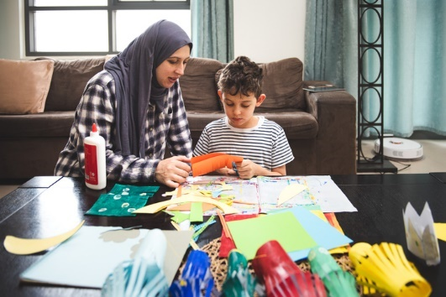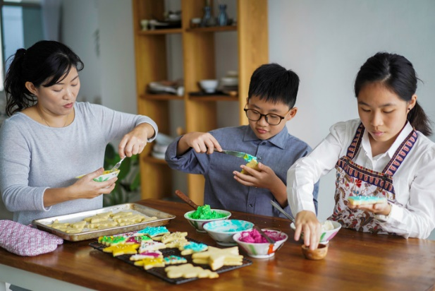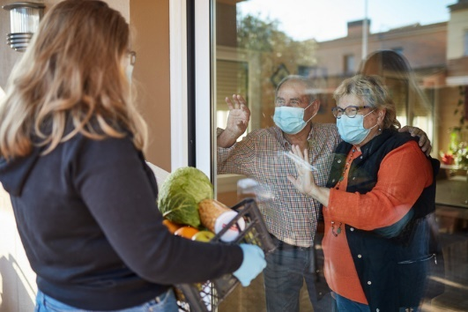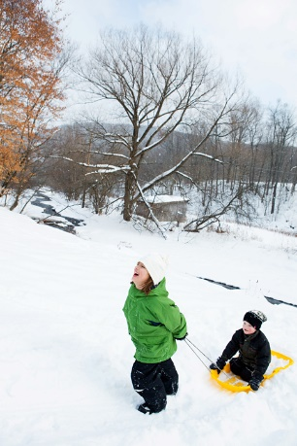

Resources
- COVID-19 in Vermont (Department of Health)
- Holiday celebrations during COVID (CDC)
- Information for Vermont’s businesses (ACCD)
- Information for Vermont’s Child Care Programs (CDD)
- Mental Health Support

