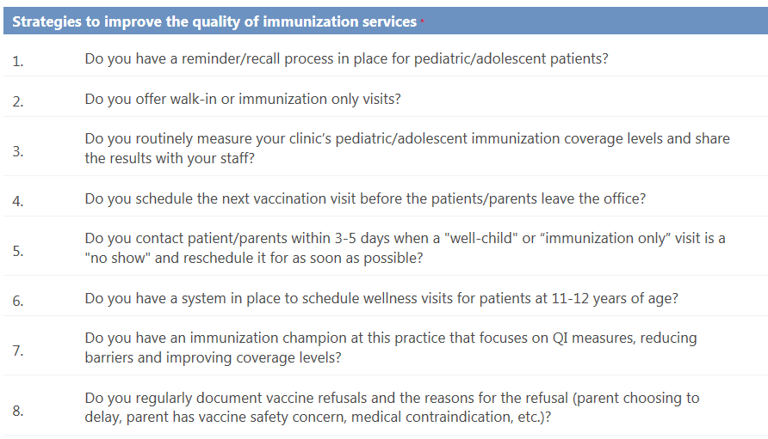
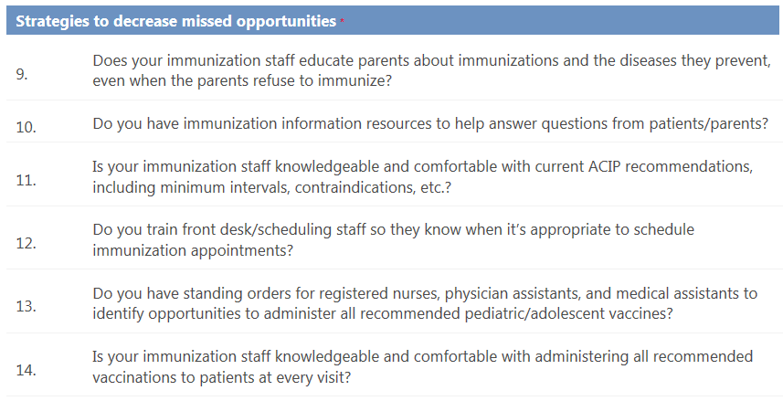
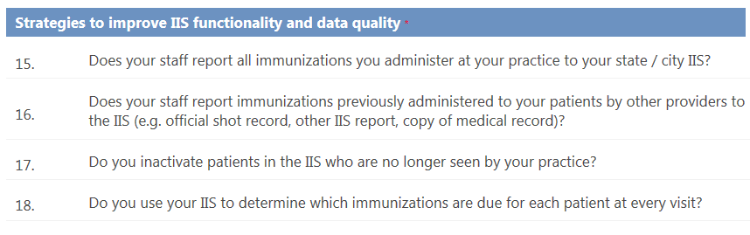
IIS: Immunization Information Systems, in Vermont, the Immunization Registry or IMR
Comparison with Healthy People 2020 Target
Up to Date (UTD): 24 through 35 Months

Vaccine | Practice % | County %  (19-35 mo) | Vermont %  (19-35 mo) | HP 2020 Target %
4 DTaP |  |  |  | 90
UTD IPV |  |  |  | 90
1 MMR |  |  |  | 90
UTD Hib |  |  |  | 90
UTD HepB |  |  |  | 90
1 VAR |  |  |  | 90
UTD PCV13 |  |  |  | 90
Series above |  |  |  | 80

Up to Date (UTD): 13 through 17 Years
Vaccine | Practice % | County %  (13-18 yr) | Vermont %  (13-18 yr) | HP 2020 Target %
UTD HepB |  |  |  | -
2 MMR |  |  |  | -
2 VAR |  | - | - | 90
1 Tdap |  |  |  | 80
UTD MCV |  |  |  | 80
3 HPV (m&f) |  |  |  | 80

